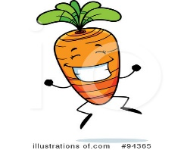 | MONDAY | TUESDAY | WEDNESDAY | THURSDAY | FRIDAY
BREAKFAST | Muffin  Yogurt  Banana  Milk | Bagel w. Cream Cheese  Oranges  Milk | Chex Cereal  Hash Browns Peaches  Milk | Waffles  Chicken Sausage  Fruit Cocktail  Milk | Cheerios  Blueberries  Milk
AM Snack | Animal Crackers  Water | Fruit Cup  Water | Nurtigrain Bar  Water | Apple Straws  Water | Club Crackers  Orange Juice
LUNCH | Turkey Sandwich  Strawberries  Green Beans  Milk | Cheese Pizza  Apple Sauce  Corn  Milk | Fish Sticks  Sweet Potato Fries  Blueberries  Green Beans  Milk | Chicken Nuggets  Pears  Sweet Peas  Wheat Bread  Milk | Mac & Cheese  Oranges  Mixed Veggie  Wheat Bread  Milk
PM SNACK | Cheerios  Milk  OJ | Cucumbers & Ranch  Wheat Crackers  Milk | Oranges  Waffers  Water | Goldfish  Milk | Granola Bars  Milk

